**Name: Yashvardhan Gupta**

**CSE B**

**Roll no.55**

**Reg no. 230905442**

**ES LAB7 19.2.25**

**SOLVED**

**Q.** WAP to simulate 4-digit BCD down counter on the multiplexed seven segment display.

**CODE**

#include<LPC17xx.h>

unsigned char tohex[10]={0X3F, 0X06, 0X5B, 0X4F, 0X66, 0X6D, 0X7D, 0X07,

0X7F, 0X6F};

long int arr[4]={9,9,9,9};

unsigned int i=0, j=0;

int main()

{

LPC_GPIO0->FIODIR|=0XFF0;

LPC_GPIO1->FIODIR|=0XF<<23;

for(arr[3]=0; ; arr[3]--)

{

for(arr[2]=9; arr[2]>=0; arr[2]--)

for(arr[1]=9; arr[1]>=0; arr[1]--)

for(arr[0]=9; arr[0]>=0; arr[0]--)

{

for(i=0; i<4; i++)

{

LPC_GPIO1->FIOPIN=i<<23;

LPC_GPIO0->FIOPIN=tohex[arr[i]]<<4;

for(j=0; j<1000; j++);

}

for(j=0; j<1000; j++);

LPC_GPIO0->FIOCLR|=0X00000FF0;

}

if(arr[3]==0)

arr[3]=10;

}

}**OUTPUT**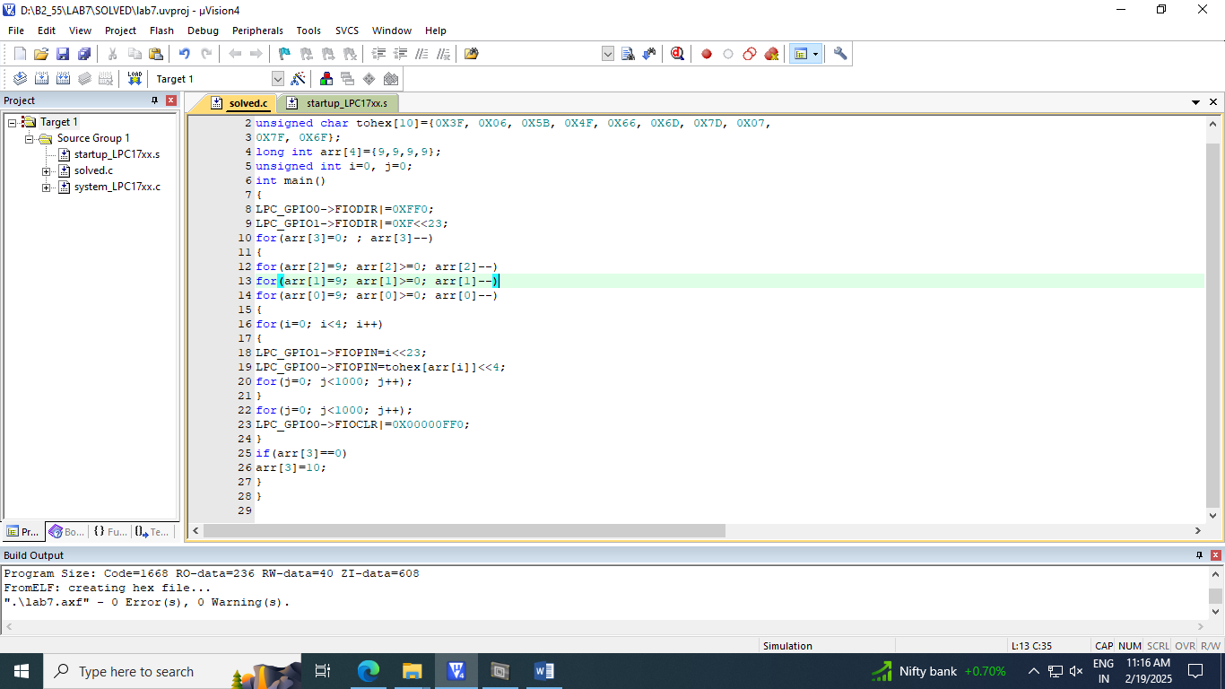

**Q1** Write a C program to display the number “1234” serially in the seven segment display

**CODE**

//To display the number 1234 serially in the seven segment display

#include<LPC17xx.h>

#include<stdio.h>

void delay(void);

void display(void);

unsigned char dec[10] = {0x3F, 0X06, 0X5B, 0X4F, 0X66, 0X6D, 0X7D, 0X07, 0X7F, 0X6F};

unsigned int dig_value[4] = {1,2,3,4};

unsigned int dig_count = 0;

unsigned int dig_select[4] = {3<<23, 2<<23, 1<<23, 0<<23};

unsigned int i;

int main(void){

LPC_GPIO0 -> FIODIR |= 0XFF<<4; //P0.4-P0.11 as output pin

LPC_GPIO1 -> FIODIR |= 0XF<<23; // P1.23-P1.26 as output pin

while(1){

delay();

display();

dig_count += 1;

if(dig_count == 4) dig_count = 0;

}

}

void display(void){

LPC_GPIO1 -> FIOPIN = dig_select[dig_count];

LPC_GPIO0 -> FIOPIN = dec[dig_value[dig_count]] << 4;

}

void delay(void){

for(i=0; i<50000; i++);//random delay

}

**OUTPUT**

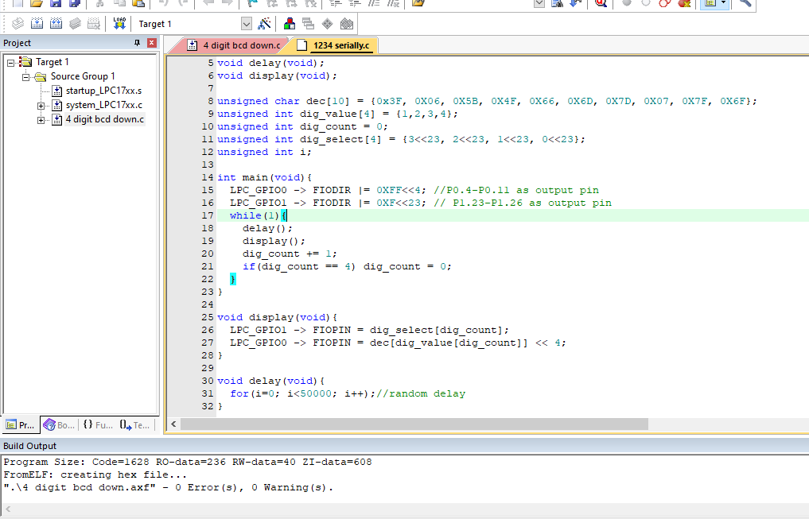

**Q2** Write a C program to simulate a 4 digit BCD down counter. Use a timer for delay.

**CODE**

//To stimulate a 4 digit BCD down counter on the multiplexed seven segment display

#include<LPC17xx.h>

#include<stdio.h>

unsigned char dec[10] = {0x3F, 0X06, 0X5B, 0X4F, 0X66, 0X6D, 0X7D, 0X07, 0X7F, 0X6F};

long int arr[4] = {9, 9, 9, 9};

unsigned int i,j;

void delay(void){

for(j=0; j<50000; j++);

}

int main(void){

LPC_GPIO0 -> FIODIR |= 0XFF0; //P0.4-P0.11 as output pin

LPC_GPIO1 -> FIODIR |= 0XF<<23; // P1.23-P1.26 as output pin

while(1){

for(arr[3]=9; arr[3]>=0; arr[3]--){

for(arr[2]=9; arr[2]>=0; arr[2]--){

for(arr[1]=9; arr[1]>=0; arr[1]--){

for(arr[0]=9; arr[0]>=0 ; arr[0]--){

for(i=0 ; i<4 ;i++){

LPC_GPIO1->FIOPIN = i<<23;

LPC_GPIO0->FIOPIN = dec[arr[i]]<<4;

delay();

}

delay();

LPC_GPIO0->FIOCLR |= 0xFF0;

}

}

}

}

}

}

**Output**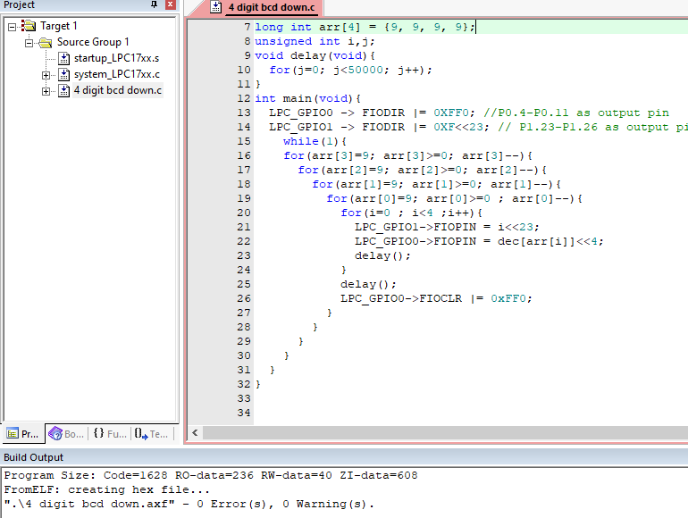

**Q3** Write a C program for 4 digit BCD up/down counters on seven segment using a switch and timer with a delay of 1-second between each count

**Code**

//4 didgit up/down counter on seven segment using a switch and a timer delay of 1 second between each count

#include<LPC17xx.h>

#include<stdio.h>

unsigned char dec[10] = {0x3F, 0X06, 0X5B, 0X4F, 0X66, 0X6D, 0X7D, 0X07, 0X7F, 0X6F};

long int arr[4] = {0, 0, 0, 0};

unsigned int i,j;

void delay(unsigned int milliseconds){

LPC_TIM0->CTCR = 0x0;

LPC_TIM0->PR = 2;

LPC_TIM0->TCR = 0x02;

LPC_TIM0->TCR = 0x01;

while(LPC_TIM0->TC < milliseconds);

LPC_TIM0->TCR = 0x00;

}

int main(void){

LPC_GPIO0 -> FIODIR |= 0XFF0; //P0.4-P0.11 as output pin

LPC_GPIO1 -> FIODIR |= 0XF<<23; // P1.23-P1.26 as output pin

LPC_GPIO2 -> FIODIR &= 0xFFFFEFFF; // P2.12 as input pin for switch

while(1){

if(LPC_GPIO2 -> FIOPIN & 1 << 12){ //switch not pressed

for(arr[3]=0; arr[3]<10; arr[3]++){

for(arr[2]=0; arr[2]<10; arr[2]++){

for(arr[1]=0; arr[1]<10; arr[1]++){

for(arr[0]=0; arr[0]<10 ; arr[0]++){

for(i=0 ; i<4 ;i++){

LPC_GPIO1->FIOPIN = i<<23;

LPC_GPIO0->FIOPIN = dec[arr[i]]<<4;

delay(1000);

}

delay(1000);

LPC_GPIO0->FIOCLR |= 0xFF0;

}

}

}

}

}else{ //switch pressed

for(arr[3]=9; arr[3]>=0; arr[3]--){

for(arr[2]=9; arr[2]>=0; arr[2]--){

for(arr[1]=9; arr[1]>=0; arr[1]--){

for(arr[0]=9; arr[0]>=0 ; arr[0]--){

for(i=0 ; i<4 ;i++){

LPC_GPIO1->FIOPIN = i<<23;

LPC_GPIO0->FIOPIN = dec[arr[i]]<<4;

delay(1000);

}

delay(1000);

LPC_GPIO0->FIOCLR |= 0xFF0;

}

}

}

}

}

}

}

**OUTPUT**

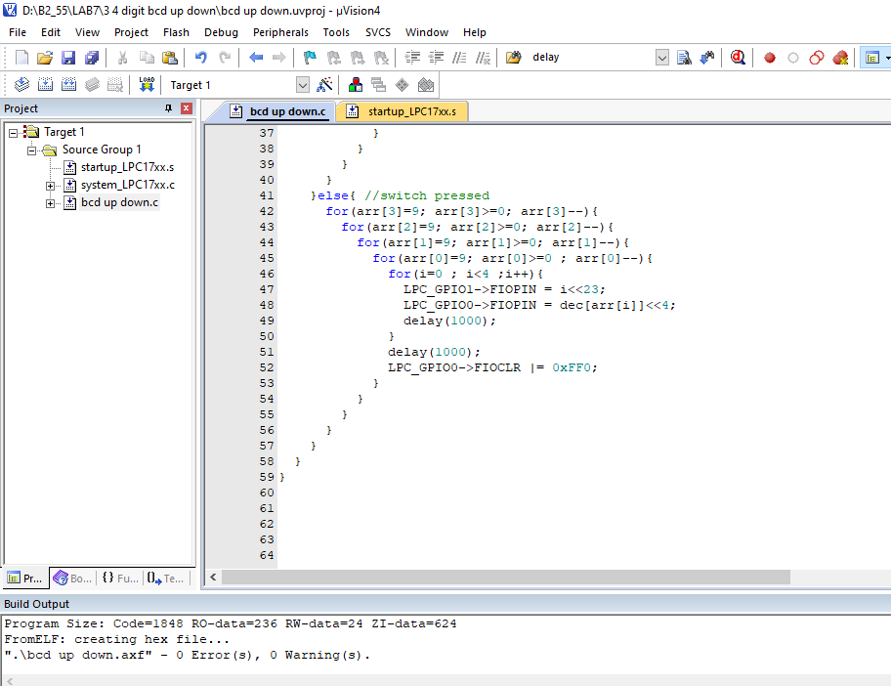

**We see that the 7 segment display is incremented, when we press SW1 button then the counter resets to 0 and starts counting from 0 again**

**Q4**Write a program for 4 digit Hexadecimal up/down counters on seven segment using a switch and timer with a delay of 1-second between each count.

**Code**

//4 digit hex up/down counter on seven segment using a switch and a timer delay of 1 second between each count

#include<LPC17xx.h>

#include<stdio.h>

unsigned char dec[16] = {0x3F, 0X06, 0X5B, 0X4F, 0X66, 0X6D, 0X7D, 0X07, 0X7F, 0X6F, 0x77, 0x7C, 0X39, 0X5E, 0X79, 0X71};

long int arr[4] = {0, 0, 0, 0};

unsigned int i,j;

void delay(unsigned int milliseconds){

LPC_TIM0->CTCR = 0x0;

LPC_TIM0->PR = 2;

LPC_TIM0->TCR = 0x02;

LPC_TIM0->TCR = 0x01;

while(LPC_TIM0->TC < milliseconds);

LPC_TIM0->TCR = 0x00;

}

int main(void){

LPC_GPIO0 -> FIODIR |= 0XFF0; //P0.4-P0.11 as output pin

LPC_GPIO1 -> FIODIR |= 0XF<<23; // P1.23-P1.26 as output pin

LPC_GPIO2 -> FIODIR &= 0xFFFFEFFF; // P2.12 as input pin for switch

while(1){

if(LPC_GPIO2 -> FIOPIN & 1<<12){ //switch not pressed

for(arr[3]=0; arr[3]<16; arr[3]++){

for(arr[2]=0; arr[2]<16; arr[2]++){

for(arr[1]=0; arr[1]<16; arr[1]++){

for(arr[0]=0; arr[0]<16 ; arr[0]++){

for(i=0 ; i<4 ;i++){

LPC_GPIO1->FIOPIN = i<<23;

LPC_GPIO0->FIOPIN = dec[arr[i]]<<4;

delay(1000);

}

delay(1000);

LPC_GPIO0->FIOCLR |= 0xFF0;

}

}

}

}

}else{

for(arr[3]=15; arr[3]>=0; arr[3]--){

for(arr[2]=15; arr[2]>=0; arr[2]--){

for(arr[1]=15; arr[1]>=0; arr[1]--){

for(arr[0]=15; arr[0]>=0 ; arr[0]--){

for(i=0 ; i<4 ;i++){

LPC_GPIO1->FIOPIN = i<<23;

LPC_GPIO0->FIOPIN = dec[arr[i]]<<4;

delay(1000);

}

delay(1000);

LPC_GPIO0->FIOCLR |= 0xFF0;

}

}

}

}

}

}

}

**OUTPUT**

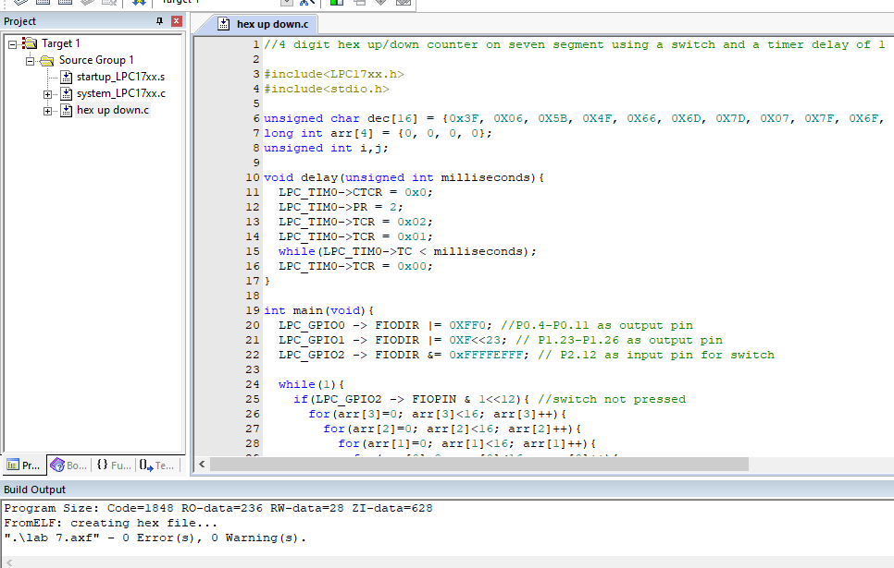

**We can see that it starts incrementing up till 9 and then counts in hexadecimal.**